**Artificial Intelligence**

**Abdurrahman Qureshi, Azlan Ahmed**

*Department of Computer Engineering,*

*M. H. Saboo Siddik Polytechnic, Byculla*

[qabdurrahman05@gmail.com](mailto:qabdurrahman05@gmail.com)

[azlanahmed@gmail.com](mailto:azlanahmed@gmail.com)

**Abstract*: -***

**Artificial Intelligence (AI)** is a field of computer science that has undergone significant growth and development over the past few decades. From its early beginnings in simple rule-based systems, AI has evolved to encompass a wide range of techniques including machine learning, deep learning, natural language processing, and more. This paper provides a technical review of the evolution of AI, covering its history, major breakthroughs, and current state

**Introduction**

The concept of **AI** dates back to the 1950s, when researchers first began exploring the idea of creating machines that could think and learn like humans. However, progress was slow in the early years, and it wasn't until the 1980s that AI began to gain wider recognition and acceptance as a legitimate field of research.

Since then, AI has undergone rapid development and has become an increasingly important technology in areas such as medicine, finance, and transportation.

**Overview of AI:**

Artificial Intelligence (AI) is a rapidly advancing field of computer science that involves the development of machines and systems that can learn from data and perform tasks that typically require human intelligence, such as speech recognition, language translation, and decision-making. Recent advances in AI, such as deep learning and natural language processing, have made it possible to develop more sophisticated models that can solve increasingly complex problems. AI has applications in various industries, including healthcare, finance, and transportation, and is expected to continue to transform the way we live and work in the future.

**Early AI**

In the early days of AI, researchers focused primarily on developing rule-based systems that could perform simple tasks. These systems were designed to follow a set of predetermined rules and were not capable of learning or adapting to new situations.

One of the earliest examples of an AI system was the Logic Theorist, developed by Allen Newell and Herbert Simon in 1955. The Logic Theorist was able to prove mathematical theorems by following a set of logical rules.

In the 1960s and 1970s, researchers began to develop more advanced AI systems that could reason and solve problems in more complex domains. One notable example, The General Problem Solver was able to solve a wide range of problems by breaking them down into smaller sub-problems and applying a set of problem-solving rules.

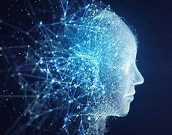

**What is MACHINE LEARNING?**

The breakthrough that really propelled AI forward came in the 1980s with the development of machine learning algorithms.

Machine learning is a subfield of AI that involves training algorithms on large datasets to recognize patterns and make predictions.

One of the earliest examples of machine learning was the backpropagation algorithm, developed by David Rumelhart, Geoffrey Hinton, and Ronald Williams in 1986. Backpropagation is a method for training artificial neural networks, which are algorithms that are modelled after the structure of the human brain.

**Self-Driving Vehicles**

The development of self-driving cars, also known as autonomous vehicles, is a prime example of how AI is being applied in driving.

Self-driving cars use a combination of sensors, cameras, and AI algorithms to navigate roads and make decisions about steering, braking, and acceleration. The sensors and cameras gather information about the environment, including other vehicles, pedestrians, and road signs, and the AI algorithms analyse this data to make decisions about how to drive the vehicle.

One of the key benefits of self-driving cars is the potential to reduce the number of accidents caused by human error.

Another benefit of self-driving cars is the potential to increase accessibility for people who are unable to drive, such as the elderly or those with disabilities. Self-driving cars could also reduce traffic congestion and improve the efficiency of transportation systems.

However, there are also challenges associated with the development and deployment of self-driving cars, including regulatory issues, cybersecurity concerns, and the need for continued testing and refinement of AI algorithms to ensure their safety and reliability on the road.

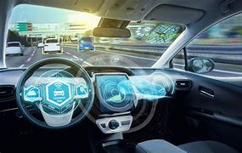

**Help in Medical**

Artificial Intelligence (AI) has been increasingly used in the field of medicine to help diagnose diseases, develop treatment plans, and improve patient outcomes. Here are some examples of how AI is being used in medicine:

* **Medical Imaging:** AI algorithms can analyse medical images such as CT scans, MRI scans, and X-rays to detect abnormalities and help diagnose conditions such as cancer, heart disease, and brain disorders.
* **Personalized Medicine:** AI algorithms can analyse a patient's genetic data and medical history to develop personalized treatment plans based on their unique needs and medical conditions.
* **Drug Discovery:** AI algorithms can help identify potential drug candidates and accelerate the drug development process by predicting how different compounds will interact with the body.
* **Clinical Decision Support:** AI algorithms can provide healthcare providers with real-time information and guidance to help them make more accurate diagnoses and treatment decisions.
* **Robot-Assisted Surgery:** AI-powered surgical robots can assist surgeons during procedures, allowing for greater precision and improved outcomes.

While AI has the potential to revolutionize medicine and improve patient outcomes, there are also concerns around data privacy, regulatory compliance, and ensuring that AI-powered tools are safe and effective.

**Future of AI**

The future of Artificial Intelligence (AI) is promising, with new developments and advancements in the field constantly emerging. Here are some future aspects of AI:

* **Increased Automation:** AI will continue to automate tasks in various industries, including healthcare, finance, and transportation. This will lead to greater efficiency, reduced costs, and improved outcomes.
* **Continued Development of Self-Driving Cars:** The development of self-driving cars will continue to advance, with the potential to transform the way we travel and reduce accidents caused by human error.
* **Enhanced Robotics:** AI-powered robots will become more sophisticated and capable of performing complex tasks, such as manufacturing, construction, and even surgery.
* **Increased Personalization:** AI will enable more personalized experiences for consumers, such as personalized healthcare, education, and entertainment.
* **Ethical Considerations:** Ethical frameworks will need to be developed to ensure that AI is used in a responsible and fair manner.

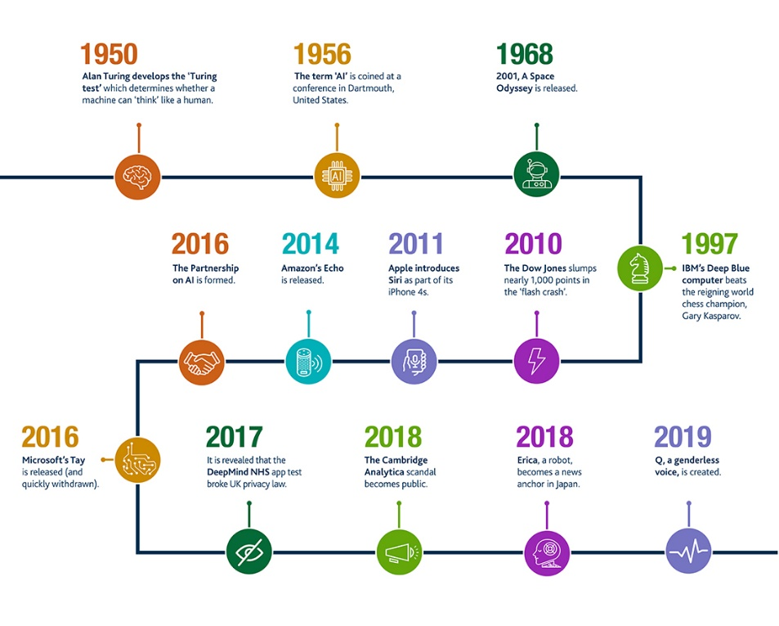

**Conclusion**

In conclusion, Artificial Intelligence (AI) has emerged as a game-changing technology that has the potential to revolutionize various industries and transform the way we live and work.

From self-driving cars and personalized medicine to advanced robotics and enhanced natural language processing, the future of AI is promising.

As AI continues to evolve, it is likely to become an increasingly important part of our lives, and it is essential that we stay informed and engaged in its development and implementation.

**Refrences**

* LeCun, Y., Bengio, Y., & Hinton, G. (2015). Deep learning. Nature, 521(7553), 436-444.
* Rajkomar, A., Dean, J., & Kohane, I. (2019). Machine learning in medicine. New England Journal of Medicine, 380(14), 1347-1358.
* Manyika, J., Chui, M., Miremadi, M…,(2017). A future that works: Automation, employment, and productivity. McKinsey Global Institute.
* Pearson, C. (2018). Ethics and artificial intelligence: A guide for the perplexed. Harvard Business Review.
* World Economic Forum. (2020). The Global Risks Report 2020